cAR: Contact Augmented Reality with

Transparent-Display Mobile Devices

1st Author

1st author's affiliation  
1st author's E-mail address

2nd Author

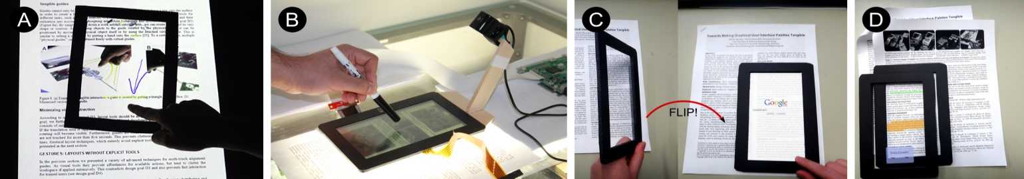

Figure 1: We implement the concept of Contact Augmented Reality (cAR) with two prototypes and apply it to active reading tasks. A- A tabletop prototype generated early feedback on use cases of cAR. B- tPad, a transparent tablet prototype. C- Flipping the device triggers an online-search for selected content (mock-up). D- Stacking of devices is possible for content sharing (mock-up).

2nd author's affiliation  
2nd E-mail

3rd Author

3rd author's affiliation  
3rd E-mail

**ABSTRACT**

We present Contact Augmented Reality (cAR), a form of AR where a mobile device with a transparent display rests on top of the augmented object. cAR is based on the notion that interactions with digital content are enriched by the tangibility of physically moving a device on and off the augmented object. We propose and implement three categories of cAR interaction techniques: contact-based, off-contact and content-aware. We built two cAR prototypes and explore how cAR can be applied to the domain of active reading. A first low-fidelity prototype, consisting of an interactive tabletop and transparent acrylic tangibles, allowed us to iteratively design and test interaction techniques. The second and higher-fidelity prototype, called a tPad, uses a semi-transparent touch-enabled 7” LCD display that is placed on top of back-lit paper documents. The tPad uses an external camera and feature matching algorithms to identify the document and to determine its location and orientation. We report on user feedback on cAR, and elaborate on the salient technical challenges for cAR devices.

**Categories and Subject Descriptors**

H.5.2 Information Interfaces and Presentation: User Interfaces: Input Devices and Strategies, Interaction Styles.

**Keywords**

Contact Augmented Reality, Transparent Devices.

# INTRODUCTION

Novel transparent display technologies allow users to view virtual content and physical objects at once, enabling new forms of interaction. Current research and conceptual designs portray transparent display mobile interactions [8, 9] as extensions of mobile Augmented Reality (AR) applications. Mobile AR overlays virtual content on top of images from the real-world captured using the mobile camera. Transparent display mobile AR bypasses the digital image of the world, as it can be seen directly with the naked eye.

However, transparent display mobile AR faces challenges derived from the display transparency. To determine the pixel location of digital content the system requires the relative locations of world objects, the device and the user’s head and gaze. Also, binocular parallax affects how users perceive content alignment and their capacity to perform touch interactions [10]. These challenges of object tracking and binocular parallax are proportional to the distance between the device and the objects it augments. Conversely, when display and objects are in direct contact, the challenges are minimized. Direct contact provides spatial alignment between the display and the object, simplifying the *registration* and *rendering* processes [2, 4]. *Registration* is reduced to identifying the object below the device and calculating their relative 2D locations/orientations. *Rendering* does not require perspective corrections.

Permission to make digital or hard copies of all or part of this work for personal or classroom use is granted without fee provided that copies are not made or distributed for profit or commercial advantage and that copies bear this notice and the full citation on the first page. To copy otherwise, or republish, to post on servers or to redistribute to lists, requires prior specific permission and/or a fee.

*Conference’10*, Month 1–2, 2010, City, State, Country.

Copyright 2010 ACM 1-58113-000-0/00/0010 …$15.00.

Our work explores the interactions between transparent display mobile devices and physical objects directly underneath and in contact with the display; we call it *Contact Augmented Reality* (cAR). cAR renders virtual content on top of physical artefacts, such as maps [19] or text documents [1], while preserving the affordances of tangible objects. A user browsing a physical foldout of a map can place a cAR device on top of it to highlight points of interest, draw routes and make notes on the device, without affecting the paper map. The cAR device can be lifted-off so that the user can continue browsing the physical map, flipping parts of it and checking legends without losing context. Resting the device on the map again allows the user to access other virtual content, such as videos or images associated with a specific point of interest. Finally, the cAR device shows user created content as the user re-visits previously annotated regions.

In this paper we introduce cAR and identify a set of cAR interaction techniques. To explore such techniques we built two cAR prototypes (Figure 1). A first low-fidelity prototype consists of an interactive tabletop and transparent acrylic tangibles (Figure 3). A higher-fidelity prototype, called tPad, uses a touch-enable semi-transparent 7” LCD display that is placed on top of back-lit paper documents (Figure 4). We show how cAR can be applied to the sample application area of active reading leveraging the affordances of paper and digital systems [7, 14, 17]. Finally, we gather user feedback and discuss the technical challenges of cAR.

# CONTACT AUGMENTED REALITY

Our conceptualization and implementation of cAR is guided by the vision that printed material is intertwined with rich amounts of digital content. Wall posters, newspapers, book pages, are all associated with far more content, and in much diverse formats (multimedia), than is possible to etch in ink. With cAR, associated content can be retrieved by simply placing a transparent-display mobile device directly on top of the object, be it a poster, map, or newspaper. While existing devices already offer access to digital information by means of mobile AR, cAR is based on the notion that interactions with the digital can be enriched by the tangibility of physically moving a device on top of the augmented object.

We identify three categories of interaction techniques for cAR devices: First, *contact-based* interactions, e.g. placing the device on a newspaper could retrieve additional data about that object such as audio or video. Second, *off-contact* interactions, e.g. information between devices can be easily exchanged by stacking one on top of another. Third, *content-aware* interactions, e.g. tapping on words triggers a search. Other interactions within these categories include content extraction, scribble triggers, orientation to content, and flipping for dual-side access.

For cAR to operate, the fundamental requirement is to establish a frame of reference between the device and the object to augment (a coordinate system). cAR interactions require knowing the 2D location of the device relative to the origin of the physical object’s coordinate system. This implies that, for example, using a cAR device on a book while in bed or while sitting on a table makes no difference when determining their relative locations. An important consequence of the spatial alignment between the transparent display and the augmented object is that digital content is rendered on a virtual plane parallel to the object surface; this means that homographic transformations are not required.

In summary cAR integrates virtual and physical worlds by:

* augmenting physical objects upon contact,
* preserving the affordances of physical objects,
* integrating display and input functionalities, and
* simplifying registration and rendering to two dimensions.

# RELATED WORK

cAR builds on work in augmented reality, magic lenses and transparent portable devices.

## Augmented Reality

*Augmented Reality* (AR) enhances the real world by embedding digital content onto it. Bimber and Raskar list three basic AR challenges: display technology, registration and rendering [4]. The display technology determines the complexity of the other two. *Traditional AR* relies on mobile displays carried by the users (e.g. smartphones, pico-projectors, HMDs) allowing the augmentation of any object within the display’s field-of-view but requiring complex operations for registration (i.e. 3D object recognition) and rendering (i.e. field-of-view and perspective calculations). Moreover, mobile displays present limitations in terms of resolution, focus, lighting and comfort. A complete reference to AR technologies and applications can be found here [2]. On the other hand, *Spatial AR* (SAR) primarily relies on displays fixed in the environment (e.g. projectors, transparent LCDs) [4]. Knowing the location of the display and the augmented object provides SAR applications with *spatial alignment*, a linear correspondence between virtual content and real world objects. Spatial alignment facilitates the creation of AR applications because the registration and rendering operations required are simpler.

Contact Augmented Reality (cAR) incorporates elements from both traditional and spatial AR. From traditional AR it maintains the vision of a mobile device that augments any object and is carried around by the user. From spatial AR it incorporates the property of spatial alignment, thus the knowledge about the location of both display and object and their correspondence. In brief, cAR is both mobile and spatially aligned.

## Magic Lenses and Tangible Views

cAR is inspired by Bier et al.’s Toolglass and Magic Lenses [3]. Toolglass and magic lenses for WIMP interfaces sit between the application and the cursor to provide rich operations and visual filters on the digital content. For example, a toolglass widget can have different areas each with unique operations, such that by clicking the target object through the toolglass the digital content is modified in different ways. Similarly, the magic lens widget can hide or show details of an underlying digital object by placing the widget on top of it. Moving beyond WIMP, Mackay et al.’s implemented a tool-glass and magic lens approach to augmenting a biology laboratory book [12]. Researchers built physical magic lenses using transparent acrylic plates with fiducial markers [9] and head tracking [21]. Similarly, non-transparent tangible views provide secondary displays for tabletops to be used as physical lenses [18], application menus [23] or selection proxies [16].

cAR, a concept developed for transparent mobiles, encapsulates ideas from toolglasses and magic lenses. With cAR, the physical object is visible and modifications happen on its digital model. Our cAR devices advance existing implementations [12, 9, 16] by using actual semi-transparent displays, feature-based tracking and exploring off-contact and content-aware interactions.

## Transparent Handheld Devices

Transparent handheld devices are the subject of popular design concepts [5, 6]. Such concepts are instrumental in proposing novel interactions (some of them similar to the ones we explore); however they do not discuss usage contexts and technical limitations. While such devices are becoming commercially available (e.g. Lenovo S800), we possess limited understanding of the breadth of interaction techniques they afford. One explored aspect is their support for touch interaction on the back of the device. LucidTouch [25] and LimpiDual [15] studied back-the-device touch to overcome the fat-finger and finger occlusion problems. Lee et al. [10] studied the binocular parallax problem.

Our work moves beyond such problem-specific foci to include a broad range of techniques for augmenting objects upon contact. Glassified [22] and ClearPlate [13] embody certain aspects of the cAR vision. In this paper, we propose a conceptual framework for cAR and present two alternative implementations.

# cAR INTERACTION TECHNIQUES

Figure 2 shows three categories of cAR interaction techniques: *contact-based,* *off-contact* and *content-aware*. Other approaches to AR focus largely on *content-aware* interactions. Although *off-contact* techniques resemble other non-AR technologies [23], the cAR versions are performed on top of the object.

## Contact-based

Contact-based interactions are manipulations of the cAR device in relation to the object below.

*Placing/Removing* – The basic cAR interaction is placing the device on top of the augmentable object. Upon contact, the device identifies the object below and responds to it. In simple cases the device adapts to simple properties like color or type (e.g. text, drawing, skin, paint, etc.). In complex cases, such as maps, the device accesses a model of the underlying object. Conversely, removing the cAR device changes mode or exits the system.

*Translation* – An application uses translation to accommodate virtual content and maintain alignment with the object.

*Rotation* – Rotation can be relative to the original placement or to the object’s “north”. For example, rotation could be used to change display settings like opacity and zoom factor.

*Freezing* – When freezing the device ignores changes in translation and rotation and users move the device freely while preserving the application state, e.g. the current view in the virtual plane. For example, once triggered, video content is reproduced regardless of changes on the device’s location.

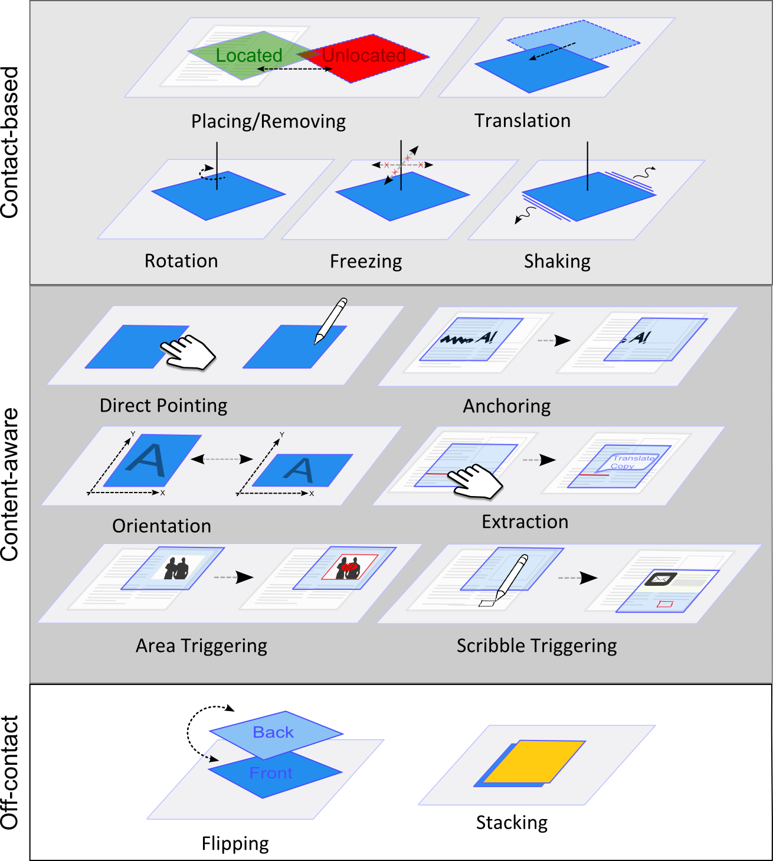  
Figure 2. cAR interaction techniques grouped by the three identified categories.

## Off-Contact

Off-contact interaction techniques do not require the cAR device to lie on the augmented object.

*Flipping* – A cAR device can be flipped around to bring the other side of the screen on top and perform visual changes such as zooming, inverse color filters, language translation, or launching a secondary application for the actual document.

*Stacking* – A cAR device can be stacked on top of another one. Given that both displays are transparent, the digital content of both devices and the physical object could be visible at once. This interaction can be used to support content sharing: digital content from one device is pulled up or pushed down between devices.

## Content-Aware

Content-aware interaction techniques leverage knowledge about the underlying physical object.

*Direct Pointing* – Direct pointing allows users to use their finger or stylus to interact with spatially-aligned digital content, click on user-interface elements such as buttons menus, or issue gestures.

*Extraction* – Users can interact with elements of the digital model. For example, a cAR magazine app allows users to select words and look up definitions and their occurrences in the document.

*Triggers* – Triggers are regions of the physical object that activate special responses by the cAR device. Triggers can be area-based or scribble-based. Area-based triggers are zones statically defined in the object, such as an image which triggers associated video. Scribble-based triggers are hand-drawn glyphs which are read and interpreted by the cAR device; e.g. a hand-drawn square launches the calculator application by moving the cAR device on top of it.

*Anchoring* – Anchoring refers to attaching digital content to a fixed location on the physical object. For example, digital hand-written notes can be anchored to paragraphs of a paper book.

*Orientation* – A cAR application can adjust the orientation of its user-interface based on the coordinate system of the augmented object. This technique resembles adaptation of mobile phone interfaces to the way users hold them (portrait vs. landscape).

# cAR EXAMPLE: ACTIVE READING

We demonstrate cAR interactions in active reading scenarios [1], a kind of reading used to self-inform, cross-reference or support discussion. Our goal is not to create an active reading system that outperforms existing ones [7, 14, 17, 20], our interest is to use active reading as an example application area to explore a range of cAR techniques. Based on existing work, some basic features for active reading include: outlining, underlining, highlighting, searching, scribbling, digital annotations, note-taking, information seeking, comparing, and content sharing.

Figure 1 (front page) shows prototypes and sketches with different active reading features and the supporting interaction techniques. For example, users can add hand-written notes using touch (Figure 1A) or a stylus (Figure 1B), perform an online search on a selected word by simply flipping the device (Figure 1C), and share content by stacking devices (Figure 1D). Table 1 shows the complete set of mappings between interaction techniques and active reading features for each of our prototypes.

|  |  |  |
| --- | --- | --- |
| **Technique** | **Active Reading Feature** | **Prot** |
| Placing/Rem. | Document recognition, access, exit | Both |
| Translation/ Rotation | Browsing virtual content anchored to locations in the document. | Both |
| Freezing | Ignores translation and rotation, thus maintaining the current digital view. | tPad |
| Shaking | Undo for highlights and scribbles | tPad |
| Direct Pointing (hand and pen) | UI interaction, creating and manipulating digital contents | Both |
| Anchoring | Adds notes and scribbles to fixed locations of the physical document. | Both |
| Orientation | Adjust the UI to the text orientation | tPad |
| Extraction | Selecting words from the text for the purpose of in-document search, online search, and translation. | Both |
| Area/Scribble Triggers | Starting a video when hovering an image, and launching app when hovering a particular glyph. | tPad |
| Flipping | Full screen online-search of selected word, and magic-lens color filter. | TT |
| Stacking | Content sharing between devices. | tPad |

Table 1. Mapping between cAR interaction techniques, active reading features and the Tabletop (TT) and tPad prototypes.

# TABLETOP PROTOTYPE

We built a tabletop prototype to support our design process by allowing fast prototyping and testing of design alternatives without the technical complexities of a high-fidelity prototype.

Conceptually, the physical documents (books or sheets of paper) are substituted with the interactive surface of the tabletop which also provides touch input capabilities. The cAR device itself is simulated by a transparent square that is spatially tracked on the tabletop via fiducial markers, and different markers on both sides enable flipping. A document viewer shows the document to augment, aligns the created content to the actual page, and extracts the words users tap on for further interaction. The UI for the simulated device is shown at the location and orientation of the probe, giving the impression of a translucent display that can be moved freely on top of a document.

## Implementation

We implemented the prototype on a Samsung SUR40 tabletop as seen in Figure 3. We attached Microsoft ByteTags to a 7” acrylic glass probe using IR reflective foil to minimize obtrusiveness.

The prototype supports touch and pen input (IR pen) (Figure 3C-D). We implemented the following features: users can write free-hand annotations or highlight text (Figure 3A), tap on figures to show an overlay with additional information (e.g. video), or tap on references to show the corresponding bibliographic entry. Flipping the display after selecting a word, switches to a web browser showing an online encyclopedia’s entry for the word (Figure 3B). If nothing is selected, a color-inverted view is shown, illustrating different ways of presenting content (Figure 3C).

While this prototype is well suited for rapid prototyping it is also limited. The transparent probe lacks its own display which limits the real experience of a transparent device like weight, or facing a transparent display’s problems such as color blending problem and limited color [24]. Moreover, the tabletop cannot accurately simulate the haptics of real paper or other physical objects: users cannot grab the paper, move it around or feel its texture.

## User Feedback

We gathered early user feedback on cAR interactions from eight participants (2 female, 28 years old in average) using the tabletop prototype. After introducing participants to cAR and active reading, a researcher demonstrated the interaction techniques and asked the participant to perform them. Then we conducted a semi-structured interview about the interactions (~30 minutes) and participants could use the prototype while answering questions.

### cAR and Interaction Techniques

In general participants appreciated the cAR concept and its usage for active reading. Participants highlighted the value of getting access to information not already included in the text (e.g. video or color images) as well as the benefits of having highlights and annotations in digital format for later use. Some users indicated it would be better suited for books (rather than for short documents) and for situations where a table is available to limit fatigue from holding the device against, e.g., a poster in the wall.

Users easily grasped the value of the *translation*, *rotation*, *direct pointing*, and *anchoring* interactions, and their effects on the contents on the display (e.g. menus) and on the virtual layer (e.g. scribbles and notes). Similarly, they appreciated *extraction*, and suggested other usages like translation and social media sharing. On the other hand, *flipping* received mixed reactions and was perceived to be laborious (6 participants). This may have been influenced by the 7” size and limitations of the prototype.

### Active Reading Support

Feedback was mixed for both highlighting and annotating: For three participants, these were the most important features of the prototype, while the others did not see a clear advantage of combining digital annotations with physical, printed documents and preferred techniques similar to desktop readers instead of free-hand marking and scribbling. These opinions might have differed if our tests included maps, as such documents are often marked heavily [19]. Two participants mentioned the importance of keeping track of the annotations location, pointing to the need for overviews of the digital content or off-screen markers. Finally, participants mentioned the possibility to export such annotations and extracted content to other digital formats, ranging from simple clipboard functionality to integration of some form of social network for sharing comments about specific parts of a document.

Six participants highlighted the linking text and pictures in the physical document to additional media (e.g., videos) or metadata (e.g., reference list entries). They proposed looking up terms in an online encyclopedia, even before they were shown this feature, thinking of it as “convenient” and “quite cool”. Hence, this feature could be considered essential. Moreover, completely replacing content was also well received. Four participants mentioned zooming text for reading assistance as useful, and half of them proposed automatic translation of the text under the device.

# tPad PROTOTYPE

Our second prototype, the *tPad*, is a high-fidelity prototype we used to further explore the proposed interaction techniques and the technical challenges of building a self-contained cAR device.

Our prototype uses a semi-transparent 7 inch LCD display on top of a light table (Figure 4-top). The documents to augment are printed single sided on white paper. The light table acts as back light necessary for the LCD-based display. Future transparent displays (e.g. T-OLEDs) do not require such a setup as they emit their own light. We used an overhead camera attached to the display for registra-tion. A touch-overlay supports touch and pen input, an accelerometer enables flipping and magnetic sensors enable staking. The tPad runtime holds a PDF version of the document and meta-data as object models. The device runtime is designed as an application container with an application launcher (DashboardApp), a general purpose application (CalculatorApp), and a cAR application for active reading (ActiveReader). On startup, the DashboardApp lists the installed applications.

Figure 3.: A) highlights and scribbles, B) online-search of selection, C) inversion lens when flipping, and D) pen input.

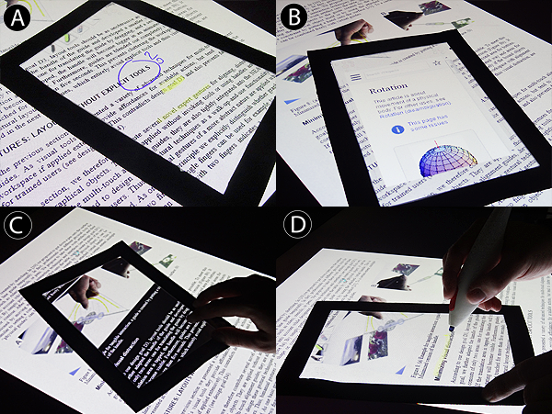

The ActiveReader application supports all the features listed in Table 1, except flipping due to the camera protrusion. The tPad includes a soft-keyboard to support text entry, and uses *rotation* to control opacity and zooming. When presented with the settings screen, the user rotates the tPad to control the transparency of the digital content. Users can also zoom into the virtual layer to “create” more space for scribbles. The device uses off-screen markers to indicate the location of off-screen anchored content.

The tPad supports the *orientation* and *freezing* interaction techniques. For orientation the ActiveReader relocates its menus according to the text flow, so that the menus are away from the main reading and interaction area, reducing the presence of fingers and stylus in the captured image – an important factors for feature-based registration (section 7.1.2). Users can also *freeze* the tPad on a particular location and the actual digital content will remain visible regardless of the device’s movements; a user could then move to a different page or pass the device to another person while having the digital content visible at that particular location.

The tPad supports *stacking* via magnetic switches and magnets embedded on the device’s frame. When physically stacked, the magnets of the device on top align with the magnetic sensors of the device below, starting a networked pairing process. Upon pairing, users can see both the physical document and the digital content of both displays. Devices share content according to three strategies: *pull all*, *pull current page*, and *pull selection*. *Pull all* transfers all annotations, scribbles and highlights in the current document created in the device below. *Pull current page* limits the transfer to the current page. *Pull selection* transfers only manually selected content. Stacking ends by explicitly selecting the un-pair button or by physically separating the devices.

Figure 4. Top – tPad system components. Bottom – tPad at runtime: scribbles, lock-in function and off-screen markers.

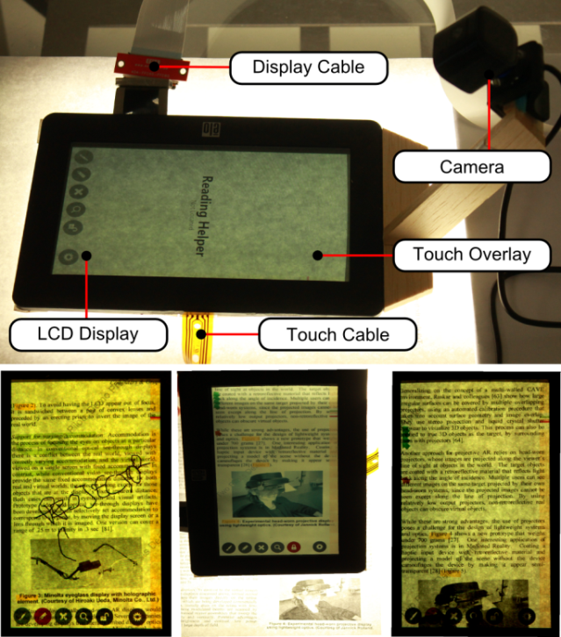

The device uses scribble-based triggers to launch specific apps. For example, placing the tPad over a hand-drawn square launches the CalculatorApp. Area-triggers launch predefined content associated to an area in the document. For example, a video is played when the tPad is placed on top of a particular image.

## Implementation

### Hardware and Software Architecture

Figure 4-top shows the hardware components used for the tPad prototype. We re-purposed a 7’’ inch semi-transparent LCD resistive-touch USB display by removing the backlight. The tPad rests on top the physical papers it augments (one sheet of paper at a time) which in turn rest on a custom-built D65 light table (glass table with fluorescent lights underneath). Display and touch overlay are connected to the original display controller board. We added a Microsoft LifeCam 6000, and an Arduino Pro Micro controller board at 5V, 4 reed-switches and a ADXL335 3-axis accelero-meter. The display controller board, camera and Arduino are all connected to a computer running Windows 7. We use C# and Microsoft WPF for authoring and rendering, and C++ and OpenCV 2.4.3 for image processing and feature matching. Network messages for content sharing are JSON-encoded and sent via UDP in the local network. The ActiveReader uses the TallComponents PDF kit for accessing pixel-level information.

### Camera-based 2D registration

To determine the location and orientation of the tPad relative to the document (i.e. registration) we use the camera attached to the device and a feature-matching algorithm. The camera captures the tPad screen and the underlying surface from above, and the registration algorithm processes it against known documents. The algorithm detects the position of the captured image within a digital version of the physical document by matching features from the captured image with features from the document. The location of the image (page number, x-y coordinates, and rotation) maps the tPad location to the printed version of the document.

Our approach is similar to PACER’s [11] using FAST (Features from Accelerated Segment Test) keypoints and Fast Retina Keypoint (FREAK) descriptors. However, our process has two differences: the camera works from a fixed perspective and the captured-image contains non-matching objects like display content, fingers and reflections. Figure 5 shows the results of our registration algorithm tested at the center of the 10 pages of our sample document [2] at 9 different angles and under three levels of obtrusion: without screen, screen (no content shown) and partly occluded (a finger touching the middle of the display). Results show our matching algorithms work efficiently for most angles, with performance decreasing with the image quality (with screen and partially occluded conditions), particularly for angles between 45 and 90 degrees. Results demonstrate the feasibility of a self-contained camera-based cAR device, noting that further research is needed for different usage conditions, display technologies, and better camera integration [13].

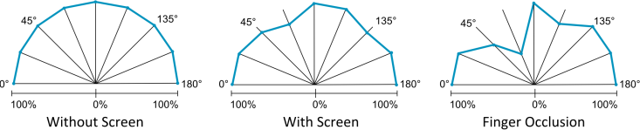

Figure 5. Registration accuracy at different angles and usages.

### Technical Limitations

Even though hand-held and mobile, our tPad is limited by the need of a light table. Nonetheless, both hardware and software architecture were designed for a self-contained device, meaning it all could work with minimal modification when transparent OLED displays become available. On the other hand, registration works at only 10 FPS approximately. The prominence of the camera keeps us from exploring flipping, and touch and pen input are limited to a single side. Finally, the nature of LCD displays limited our exploration of stacking as the display on-top did not receive enough backlight.

# DISCUSSION

Our two prototypes and user evaluation demonstrate how cAR differs from existing approaches to mobile AR. Activated when placing the device on top of that augmented object, cAR breaks apart from the current mobile AR paradigm, where an application has to be invoked explicitly, and uses an always-on paradigm supported by implicit interactions. Our experiments show that users understand and appreciate cAR, particularly in the active reading application scenario we examined. Moreover, our prototypes demonstrate its technical feasibility and highlight future challenges. The rest of this section details the main such challenges for the design and implementation of cAR devices.

A model of the object being augmented is a fundamental piece for cAR because it is the base for multiple interaction techniques (e.g. anchoring, orientation, extraction, triggers) and application features (e.g. search, video playback, etc). The question remains as to how to create such a model and distribute it to cAR devices. In the case of document-based applications such a model could be made available by, e.g., the publisher of the physical document, either as a self-contained cAR application or as a file formatted for a general purpose reader. In this case the content, meta-data, and media files should be bundled and provisioned to the device. We envision a scenario where the device, upon laying on a document for the first time, tries to locate itself within a list of known documents or, should it fail, delegates the search to a document recognition online service (e.g. Vuforia).

A major aspect of our implementation was dedicated to the camera-based registration algorithm. The main flaw we found in this approach is its impact on the device itself given that the camera is elevated from the display plane, affecting the portability of the device. Also, the feature matching algorithm is sensible to lighting conditions and device orientation, and dependent on the number of observable features. Alternative approaches for the display such as ClearPlate [13], PixelSense and hardware accelerated registration can minimize these problems.

# CONCLUSIONS

In this paper we proposed the notion of Contact Augmented Reality (cAR), presented a series of interaction techniques for cAR devices, and implemented two cAR prototypes and applications to support the sample scenario of active reading. Our first low-fidelity prototype uses a tabletop computer and transparent acrylic tangibles. User feedback showed participants understand the cAR concept and interaction techniques, and appreciate the opportunities it offers, particularly *extraction* of content for online sharing, translation and saving. Participants also highlighted the possibilities it opens for active reading such as rich-media (video), content search and references lookup. We used the insight gained from users of the tabletop prototype to design the tPad, a prototype with all of the elements necessary for a self-contained device. tPad confirmed that an image-based approach can efficiently identify a text document and determine the device’s location in a document. Moreover, the tPad helped us identify the hardware and software elements necessary to support off-contact interaction techniques (*flipping* and *stacking*). Based on our experience building both prototypes, we discussed the importance of object models and alternative for registration.

# REFERENCES

1. Adler, A., Gujar, A., Harrison, B., O'Hara, K., and Sellen, A. A diary study of work-related reading: design implications for digital reading devices. In Proc. CHI '98.
2. Azuma, R., Baillot, Y., Behringer, R., Feiner, S., Julier, S., and MacIntyre, B. 2001. Recent Advances in Augmented Reality. IEEE Comput. Graph. Appl. 21, 6.
3. Bier, E. A., Stone, M. C., Pier, K., Buxton, W., and DeRose, T. D. 1993. Toolglass and magic lenses: the see-through interface. In Proc. SIGGRAPH '93.
4. Bimber, O. and Raskar, R. 2005. Spatial Augmented Reality: Merging Real and Virtual Worlds. A. K. Peters, Ltd., Natick, MA, USA.
5. Concept Phones. (2013, March 17). Transparent Phones. [Website]. Retrieved from http://www.concept-phones. com/tag/transparent-phone/.
6. Corning Incorporated. (2013, March 17). A Day Made of Glass 2: Unpacked. The Story Behind Corning's Vision. (2012) [Video file]. Retrieved from http://www.youtube. com/watch?v=X-GXO_urMow.
7. Dachselt, R. and Al-Saiegh, S. Interacting with printed books using digital pens and smart mobile projection. In Proc. of the Workshop on Mobile and Personal Projection (MP2) @ ACM CHI 2011, 2011.
8. Iwamura, M., Nakai, T., and Kise, K. 2007. Improvement of Retrieval Speed and Required Amount of Memory for Geometric Hashing by Combining Local Invariants. In Proc. BMVC '07.
9. Kim, K., and Elmqvist, N. 2012. Embodied lenses for collaborative visual queries on tabletop displays. Information Visualization, 11(4), 319-338.
10. Lee, J.H., Bae, S.H., Jung, J., and Choi, H. 2012. Transparent display interaction without binocular parallax. In Adjunct Proc. UIST '12. ACM.
11. Liao, C., Liu, Q., Liew, B., and Wilcox, L. 2010. Pacer: fine-grained interactive paper via camera-touch hybrid gestures on a cell phone. In Proc. CHI '10. ACM.
12. Mackay, W.E., Pothier, G., Letondal, C., Bøegh, K., and Sørensen, H.E. 2002. The missing link: augmenting biology laboratory notebooks. In Proc. UIST '02. ACM.
13. Maeda, A., Hara, K., Kobayashi, M., and Abe, M. 2011. "ClearPlate" for capturing printed information: a scanner and viewfinder in one optical unit. In Proc CHI '11. ACM.
14. Matulic, F., and Norrie, M. C. Supporting active reading on pen and touch-operated tabletops. In Proc. AVI '12. 2012.
15. Ohtani, T., Hashida, T., Kakehi, Y., and Naemura, T. 2011. Comparison of front touch and back touch while using transparent double-sided touch display. In ACM SIGGRAPH 2011 Posters (SIGGRAPH '11). ACM, 2011.
16. Olwal, A. and Feiner, S. 2009. Spatially aware handhelds for high-precision tangible interaction with large displays. In Proc. TEI '09. ACM.
17. Price, M. N., Schilit, B. N. and Golovchinsky, G. 1998. Xlibris: the active reading machine. In Proc. CHI 98. ACM.
18. Reilly, D., Rodgers, M., Argue, R., Nunes, M., and Inkpen, K. 2006. Marked-up maps: combining paper maps and electronic information resources. In Personal Ubiquitous Computing.
19. Reitmayr, G., Eade, E., and Drummond, T. 2005. Localisation and Interaction for Augmented Maps. In Proc. ISMAR '05. IEEE.
20. Schilit, B., Golovchinsky, G., and Price, M. Beyond paper: supporting active reading with free form digital ink annotations. In Proc. CHI '98, pp 249-256.
21. Schmalstieg, D., Encarnação, L. M., and Szalavári, Z. 1999. Using transparent props for interaction with the virtual table. In Proc. I3D '99. ACM.
22. Sharma, A., Liu, L., and Maes, P. 2013. Glassified: An Augmented Ruler based on a Transparent Display for Real-time Interactions with Paper. In Proc. UIST '13 Demos.
23. Spindler, M., Tominski, C., Schumann, H., and Dachselt, R. 2010. Tangible views for information visualization. In Proc. ITS '10. ACM.
24. Sridharan, S.K., Hincapié-Ramos, J.D., Flatla, D., and Irani, P. 2013. Color Correction for Optical See-Through Displays Using Display Color Profiles. In Proc. VRST '13. ACM.
25. Wigdor, D., Forlines, C., Baudisch, P., Barnwell, J., and Shen C. 2007. Lucid touch: a see-through mobile device. In Proc. UIST '07. ACM.